WALEED HAMED, as the Executor of the Estate of MOHAMMAD HAMED, | Case No.: SX-2012-CV-370
Plaintiff/Counterclaim Defendant,
vs.  FATHI YUSUF and UNITED CORPORATION | ACTION FOR DAMAGES, INJUNCTIVE RELIEF AND DECLARATORY RELIEF
Defendants and Counterclaimants.  vs.  WALEED HAMED, WAHEED HAMED, MUFEED HAMED, HISHAM HAMED, and PLESSEN ENTERPRISES, INC.,  Counterclaim Defendants, | JURY TRIAL DEMANDED
 | Consolidated with
WALEED HAMED, as the Executor of the Estate of MOHAMMAD HAMED, Plaintiff,  vs. | Case No.: SX-2014-CV-287
UNITED CORPORATION, Defendant.
WALEED HAMED, as the Executor of the Estate of MOHAMMAD HAMED, Plaintiff  vs.  FATHI YUSUF, Defendant. | Consolidated with  Case No.: SX-2014-CV-278
FATHI YUSUF, Plaintiff,  vs.  MOHAMMAD A. HAMED TRUST, et al,  Defendants. | Consolidated with  Case No.: ST-17-CV-384
KAC357 Inc., Plaintiff,  vs.  HAMED/YUSUF PARTNERSHIP,  Defendant. | Consolidated with  Case No.: ST-18-CV-219

HAMED’S MOTION FOR SUMMARY JUDGMENT

AS TO CLAIM H-21 (PAYMENT OF NEJEH’S CREDIT CARD CHARGES)

- Introduction
COMES NOW Plaintiff Hamed, though undersigned counsel, pursuant to Rule 56 and the applicable Orders of the Special Master: (1) Joint Discovery and Scheduling Plan, January 29, 2018; (2) Order re Joint Motion for 40 Days, August 6, 2018, and (3) Order re Motion to Strike Hamed Claim Nos. H-41 to H-141 and Additional “Maybe” Claims, August 12, 2018. Hamed moves for a judgment that his Claim H-21 be allowed.
- Description of the “A” Claims Process Applied to this Claim

The “A” claims were created for the pre-trial analysis of certain financial transactions by Mr. Yusuf undertaken by him after litigation began—at times when he was in control of the Partnership’s accounting system and payments. Thus, the purpose of the “A” process was for Mr. Gaffney to provide any documentary support for unexplained or suspicious transactions prior to further litigation. Mr. Hamed agreed to pay for Mr. Gaffney’s assistance so that Mr. Yusuf could ‘initially’ explain and validate such transactions prior to protracted proceedings.

On August 17, 2018, John Gaffney received a document from Hamed’s counsel that listed the 101 Hamed “A” Claims (H-41 to H-141). Attached to each was the description given by Hamed in his original Partnership claim, the exhibits from Hamed’s CPA’s expert report related to the claim – listing both the old and new claim numbers— and a pre-written form (in Word) for Gaffney’s completing the analysis. Pursuant to the mutually agreed “A” process, Mr. Gaffney was to do the following—being paid a full hourly fee solely by Hamed:

1 . . .Mr. Gaffney will submit daily emails to counsel for Hamed [with copy to counsel for Yusuf] informing them of the hours worked and what was done. . . .

2. For each of the Hamed Claims numbered H-41 through H-141. . .John Gaffney will provide a written response, in his fiduciary capacity as the Partnership Accountant, to the following two items:
- interrogatory: Provide a written statement describing the transaction, with reference to when the actual activity or delivery occurred, who the persons/entities are, what amounts were involved, and whet it was for (with reference to why the funds are allegedly properly charged to the Partnership) and making reference to any checks, invoices or other relevant documents.
- Production of Documents: Attach to the above interrogatory response, the documents referenced in your response. (Emphasis underlining added.)

Because of a number of factors such as COVID, Mr. Gaffney’s “day job” and the joint movement of some “B” claims to the “A” claim list, this process has not kept pace with the “B” claims—which are almost completed. (Hamed has either settled or voluntarily dropped many of these claims. See the Special Master’s Orders #1 through #8.) There were 179 "Original Claims" of both types combined:
93 Claims have been Completed (Decided, Settled, or Withdrawn)

8 "B" Claims remain (though all but three have been addressed and are pending)

78 "A" Claims remain – for which Mr. Gaffney has completed 11 of the described analyses

The parties expect the remaining “B” claims will be completed this year. The 11 “A” claims for which Mr. Gaffney has completed analyses can be dealt with in the same manner as the “B” claims were. But this leaves 67 “A” claims—with an approximate value of $6.2 million. In January of 2022, all counsel tried to re-start the Gaffney analysis process. Exhibit A. This, and several other attempts have failed. Through no fault on his part, it is clear that Mr. Gaffney simply lacks the available time to do these in addition to his regular employment.

Several efforts have been made in good faith by counsel to reduce, settle or otherwise deal with a number of these, but these efforts have been unsuccessful. Thus, this motion for summary judgment is the first of a number of ‘brief’ attempts to end these remaining “A” claims with minimal, very succinct filings and a very compact series of hearings.
- The Description of This Claim

The description of the instant claim from those original Hamed claim materials is as follows:

HAMED CLAIM H-21: Payment of Nejeh Yusuf credit card bill

DESCRIPTION OF THIS CLAIM: Hamed's CPA noted a Bank of America credit card in the name of Nejeh Yusuf and the Partnership.

ALL INFORMATION AND RELATED DOCUMENTS KNOWN TO HAMED: Hamed's CPA interviewed Waleed Hamed regarding the credit card bill. In addition, Hamed's CPA were provided a copy of the credit card statement from Bank of America (Exhibit 281-a). Hamed's CPA also provided John Gaffney a query dated February 15, 2016 (see Attachment VII) to advise who is responsible for this liability and where is the liability recorded in the general ledger, and provide the canceled checks, bank statements, credit card statements, invoices and any other back up documentation.

INFORMATION RECEIVED BY HAMED FROM YUSUF/GAFFNEY: John Gaffney did not respond to our request.

HAMED'S CPA'S EXPERT ANALYSIS OF WHY THE CLAIM IS VALID: IRS Pub. 535 - Business Expenses states “[g]enerally, you cannot deduct personal, living, or family expenses.” —Since no audit evidence was obtained, it is impossible to conclude that the expenditures were for business related purposes. Therefore, Hamed's CPA conclude these checks would not be deductible for tax purposes under IRS Pub. 535. As such, Hamed's CPA were not able to satisfy themselves of the following management assertions: 1. Occurrence 2. Accuracy or 3. Classification, as described in AU-C 315.A128. —Hamed's CPA concluded these amounts should be returned to the Partnership to conform to the management’s assertions. —The total amount of the claim is $49,715.05.

- Hamed’s Discovery Attempts

Hamed attempted to do discovery as to this claim—but was (perhaps properly) blocked by Yusuf—who took the position that no discovery for an “A” claim could be done outside of the “A” process. On January 30, 2018, Hamed served a discovery request on Yusuf. The first request for the production of documents asked:
Request for the Production of Documents 1 of 50:
RFPD number 1 of 50 relates to Claim H-21 (previously identified as 281) – described in the claims list as "Payment of Nejeh Yusuf credit card bill."

Please provide all documents relating to or substantiating the $49,715.05 in charges attributed to Nejeh Yusuf on the Bank of America credit card statement (5474 1500 8271 1556), including, but not limited to, credit card statements and invoices substantiating the charges—and the Partnership business purpose therefore. See Exhibit 281, Exhibits to JVZ Engagement Report, September 28, 2016, bates numbers JVZ-001252-JVZ-001253.

Yusuf responded that this should have been “directed” to John Gaffney.

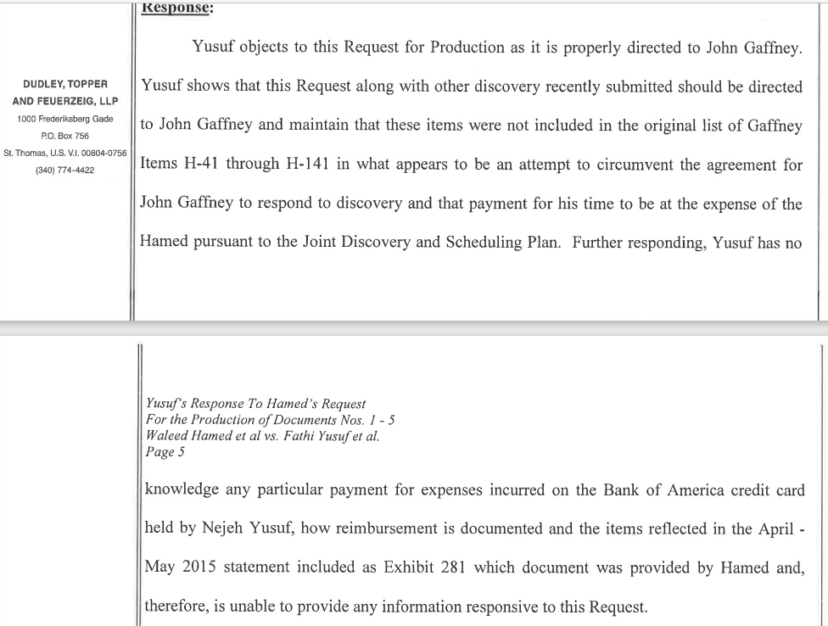

Thus, no supplemental information was received from Yusuf and there is no means for Hamed to attempt to obtain it. However, the record consists of sufficient information for summary judgment:

V. Statement of facts not in dispute

(1) there is an undisputed invoice entry paying this “Nejeh” credit card invoice (thus making it a payment by the Partnership),

(2) the expert opinion of Hamed’s CPA (Bracey Alexander) stating that lacking sufficient documentation as to a valid business charge or charges, this payment was not an allowable charge, and

(3) the sole exhibit originally provided by Yusuf—Exhibit 281-A (Exhibit B hereto). That exhibit shows what is necessary—a card in the name of “Yusuf, Nejeh”. It shows the amount charged on that card as “$49,715.05”.
- Applicable Law

What that exhibit does not show—and what is not in the accounting system materials provided to Hamed (or his CPA)—is why these unidentified “Nejeh” charges were paid by the Partnership. There is no detail or itemization. Thus, it is merely an unsubstantiated, “mere possibility” that this payment for Nejeh by the Partnership was for the Partnership and not Nejeh’s personal interests.

The Special Master has repeatedly set forth the applicable standard. Rule 56 of Virgin Islands Rules of Civil Procedure (hereinafter “Rule 56”) governs motions for summary judgment and sets forth the procedures thereto. Under Rule 56, “[a] party may move for summary judgment, identifying each claim or defense – or the part of each claim or defense – on which summary judgment is sought” and “[t]he court shall grant summary judgment if the movant shows that there is no genuine dispute as to any material fact and the movant is entitled to judgment as a matter of law.” V.I. R. CIV. P. 56; see also Rymer v. Kmart Corp., 68 V.I. 571, 575 (V.I. 2018) (“A summary judgment movant is entitled to judgment as a matter of law if the movant can demonstrate the absence of a triable issue of material fact in the record.”). “A factual dispute is deemed genuine if ‘the evidence is such that a reasonable jury could return a verdict for the nonmoving party[,]’” and a fact is material only where it “might affect the outcome of the suit under the governing law[.]” Todman v. Hicks, 70 V.I. 430, 436 (V.I. Super. Ct. April 17, 2019)(quoting Williams v. United Corp., 50 V.I. 191, 194 (V.I. 2008)).

The reviewing court must view all inferences from the evidence in the light most favorable to the nonmoving party and take the nonmoving party's conflicting allegations as true if properly supported. Kennedy Funding, Inc. v. GB Properties, Ltd., 2020 V.I. 5, ¶14 (V.I. 2020). “The movant may discharge this burden simply by pointing out to the … court that there is an absence of evidence to support the nonmoving party's case.” Id. (internal quotation marks and citation omitted).

Once the moving party meets this burden, “the non-moving party then has the burden of set[ting] out specific facts showing a genuine issue for trial.” Id. (internal quotation marks and citation omitted). The non-moving party “may not rest upon mere allegations, [but] must present actual evidence showing a genuine issue for trial.” Rymer, 68 V.I. at 576 (quoting Williams v. United Corp., 50 V.I. 191, 194 (V.I. 2008)) (Emphasis added.) “Such evidence may be direct or circumstantial, but the mere possibility that something occurred in a particular way is not enough, as a matter of law, for a jury to find it probably happened that way.” Kennedy, 2020 V.I. 5, ¶14.

Moreover, the court “should not weigh the evidence, make credibility determinations, or draw ‘legitimate inferences’ from the facts when ruling upon summary judgment motions because these are the functions of the jury.” Todman, 70 V.I. at 437 (quoting Williams, 50 V.I. at 197); see Kennedy, 2020 V.I. 5, ¶14; see also, Rymer, 68 V.I. at 577 (“When considering a summary judgment motion, a trial judge may not weigh the credibility of evidence or witnesses.”). In deciding a motion for summary judgment, the court’s role “is not to determine the truth, but rather to determine whether a factual dispute exists that warrants trial on the merits.” Todman, 70 V.I. at 437 (citations omitted); see Kennedy, 2020 V.I. 5, ¶14 (noting that the court “decide only whether there is a genuine issue for trial such that a reasonable jury could return a verdict for the non-moving party”). Accordingly, “if a credibility determination is necessary as to the existence of a material fact, a grant of summary judgment would be improper.” Rymer, 68 V.I. at 577.

Because summary judgment is “[a] drastic remedy, a court should only grant summary judgment when the ‘pleadings, the discovery and disclosure materials on file, and any affidavits, show there is no genuine issue as to any material fact.’” Rymer, 68 V.I. at 575-76 (quoting Williams, 50 V.I. at 194). The Court is required to “state on the record the reasons for granting or denying the motion.” V.I. R. CIV. P. 56(a).

Here, there are no facts in dispute.
- Argument

Hamed has shown that there was a payment by the Partnership. That the payment was for charges by Nejeh as shown on the face of the exhibit, and that there is insufficient documentation to demonstrate that this was a valid payment of an individual’s charges by a business—in the absence of detail—as shown by the expert report.

It is obvious that if the detail exits, Yusuf can easily defeat this motion by (a) submitting it as an exhibit to the opposition—the credit card statement showing the detail, along with a declaration that the itemized charges were not personal to Nejeh—i.e., were for a valid Partnership purpose; or (b) submitting his own contrary expert report. As stated above, Yusuf’s burden under the applicable law is clear:

Once the moving party meets this burden, “the non-moving party then has the burden of set[ting] out specific facts showing a genuine issue for trial.” Id. (internal quotation marks and citation omitted). The non-moving party “may not rest upon mere allegations, [but] must present actual evidence showing a genuine issue for trial.” Rymer, 68 V.I. at 576 (quoting Williams v. United Corp., 50 V.I. 191, 194 (V.I. 2008)) (Emphasis added.) “Such evidence may be direct or circumstantial, but the mere possibility that something occurred in a particular way is not enough, as a matter of law, for a jury to find it probably happened that way.” Kennedy, 2020 V.I. 5, ¶14. (Emphasis added.)

In the absence of any additional evidence, there is sufficient information in the record to show a payment for Nejeh using Partnership funds that is not supported by sufficient evidence to prevent Hamed’s claim. If, however, the motion is denied because Yusuf does come forward and shows a valid business purpose for Nejeh’s expenditures, Hamed will have to determine whether he will ask for a hearing. Absent that, Yusuf has no reasonable basis for denying the motion—just the mere possibility that the payment was for the Partnership.
- Conclusion

This is a simple accounting motion. A payment was made for Nejeh’s benefit by the Partnership. The accounting documents do not reflect that it was for a business purpose. Thus, the claim should be approved.

Dated: March 15, 2023 A

Carl J. Hartmann III, Esq.

Co-Counsel for Plaintiff

2940 Brookwind Drive

Holland, MI 49424

Email: carl@carlhartmann.com

Tele: (340) 719-8941

Joel H. Holt, Esq.
Counsel for Plaintiff
Law Offices of Joel H. Holt
2132 Company Street,
Christiansted, Vl 00820
Email: holtvi@aol.com
Tele: (340) 773-8709 Fax: (340) 773-8670

CERTIFICATE OF SERVICE

I hereby certify that on this 8th day of April, 2023, I served a copy of the foregoing by email (via CaseAnywhere), as agreed by the parties, on:

Hon. Edgar Ross

Special Master
edgarrossjudge@hotmail.com

Charlotte Perrell

Stefan Herpel

Law House, 10000 Frederiksberg Gade
P.O. Box 756
St. Thomas, VI 00802
Cperrell@dnfvi.com
Sherpel@dnfvi.com
A

CERTIFICATE OF COMPLIANCE WITH RULE 6-1(e)

This document complies with the page or word limitation set forth in Rule 6-1(e).

A

Eighteen “B” claims were later moved to this “A” list.
The original 101 “A” claims, plus the 18 added totals to 119 “A” claims. With 78 remaining, which means 41 “A” claims have been disposed of.

